201533661 이승수’s SW development exercise

<Exercise 2>

Step1: Understand the problem

Firstly, read the string at the bottom of p.13 and make up a searching for string ‘hong gil dong’.

Then, count the number of matchings and print it on the program.

Step2: Outline a solution

From first index of the string to ‘\n’, look for the target string for each indexes by moving cursor. If you found the target string, plus 1 to counting number.

Step3: Form a program structure

1. read the string and storage it.
2. Read the target string
3. Searching for the target string one by one
4. Print the counted number

Step4: Write a pseudo code

Read string.

Read target string.

While(!feof(FilePointer))

If string[index] is same as first character of the target string

While(target string is ‘\n’)

Check if string[index] is same as target string

Finally, if same, plus one for count

Print the number of count

Step5: Write the program

#pragma warning(disable:4996)

#include <stdio.h>

#include <stdlib.h>

#include <string.h>

void main()

{

char buff[1000] = {'\0',};

char target[100] = { '\0', }, temp[100] = { '\0' ,};

int CurPtr = 0, i, count = 0;

printf("Put the string that you want to search at:");

gets(buff);//문장 입력

printf("\nPut your target string:");

gets(target);//honggildong

while (CurPtr!=(strlen(buff)-strlen(target)+1))

{

for (i = 0; i < strlen(target); i++)

{

temp[i] = buff[CurPtr + i];

}

if (strcmp(temp, target) == 0)

{

puts(target);

count++;

}

CurPtr++;

}

printf("\nCount is %d",count);

getchar();

getchar();

getchar();

getchar();

getchar();

}

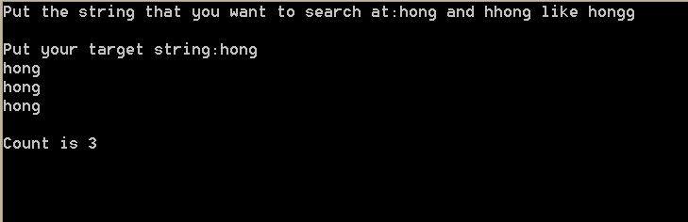

<Exercise 3>

Step1: Understand the problem

Firstly, read the main string and target string(form as string1*string2).

Then, count the number of target strings at the main string.

Step2: Outline a solution

Find for string1 at main string, then from string1, looking for string2 next. If find full target string at the main string, plus 1 to count.

Step3: Form a program structure

1. Scanf and printf the main_string and target_string;
2. Function looking for string1 in target_string;
3. From the string1, looking for string2. Find it, plus 1 to count;
4. Print the counted number;

Step4: Write a pseudo code

Void transcend(char *target,char *string1,char *string2)

Void main()

{

Printf,scanf(buff and target);

Transcend(target,string1,string2);

While(CurPtr!=(strlen(buff)-strlen(target)+1))

{

For(Get string1 to temp from buff);

If(temp==string1)

{

Find string2 and put it to temp;

}

Count++;

Curptr++;

}

Printf(count);

}

Step5: Write the program

#pragma warning(disable:4996)

#include <stdio.h>

#include <stdlib.h>

#include <string.h>

void transcend(char *target,char *string1,char *string2)

{

while(*target != '*')

{

*string1 = *target;

*string1++;

*target++;

}

*target++;//*

while (*target!='\0')

{

*string2 = *target;

*string2++;

*target++;

}

}

void main()

{

char buff[1000] = {'\0',};

char target[100] = { '\0', }, string1[100] = { '\0', }, string2[100] = { '\0', }, temp[100] = { '\0', };

int CurPtr = 0,PlusPtr, i, count = 0;

printf("Put the string that you want to search at:");

gets(buff);//문장 입력

printf("\nPut your target string:");

gets(target);//string1*string2

transcend(target,string1,string2);

printf("\ntarget:%s * %s",string1,string2);//transcend finish

while (CurPtr!=(strlen(buff)-strlen(target)+1))

{

PlusPtr = 0;

for (i = 0; i < strlen(string1); i++)

{

temp[i] = buff[CurPtr + i];

}

if (strcmp(temp, string1) == 0)

{

//puts(string1);

strcpy(temp, "\0");//cleaning the temp

do

{

for (i = 0; i < (strlen(string2)+PlusPtr); i++)

{

temp[i] = buff[CurPtr + i+PlusPtr];

}

PlusPtr++;

} while (strcmp(temp, string2) != 0);

//printf("\nresult: %s %s %s",string1,temp,string2);

count++;

}

CurPtr++;

strcpy(temp,"\0");//cleaning the temp

}

printf("\nCount is %d",count);

getchar();

getchar();

getchar();

getchar();

getchar();

}

